Human computer interaction design

**Phase #6– REVISED MANUAL for SUrveypro, an online survey system**

Table of Contents

**Hardware Requirements** 2

**Software Requirements** 2

Installation Instructions for SurveyPro 2

**Extraction of ZIP file** 2

Operation Instructions for SurveyPro 3

Bibliography 8

## **Hardware Requirements**

* You will need to have access to a computer or server in order to host and run the SurveyPro website. You must be sure your hardware can support the anticipated load.

## **Software Requirements**

* To view and use the survey platform, users of SurveyPro must have a web browser which is compatible to the device such as Google Chrome, Mozilla Firefox, Microsoft Edge, and Safari. Mostly preferred web browser to run the website is Safari.
* To upload and manage the PHP, MySQL, HTML, CSS, JQuery files on your web server, you will need an FTP (File Transfer Protocol) client. FileZilla, WinSCP, and Cyberduck are a few well-known FTP clients. Mostly preferred is XAMPP. The safe transfer of files between your local computer and the web server is made possible by this software.
* To upload and run the website, you will need to download XAMPP to host the website locally on the server.

# **Installation Instructions for SurveyPro**

## **Extraction of ZIP file**

**Option1**

* Download the Zip Archive file
* Do a right-click on the ZIP file.
* Go to the context menu and choose "Extract All."
* To specify the extraction location and start the process of extraction, follow the on-screen prompts.

**Option 2**

* Download the Zipped Archive file.
* Launch the zip file application of your choice, such as 7-Zip or WinZip.
* From within the utility, open the ZIP file.
* Select the extraction location.
* To extract the contents, use the utility's "Extract" or equivalent button.

# **Operation Instructions for SurveyPro**

After unzipping the files, please follow these easy steps to start using SurveyPro:

* Navigate to the folder where you extracted the files after extracting them in accordance with the preceding steps. This is the folder named "SurveyPro" by default.
* Copy or Move the SurveyPro Folder to the “htdocs” directory in the XAMPP(upon downloading) folder in your device.
* Then locally host the website on the server using the following path, <http://localhost/SurveyPro/admin/index.php> and <http://localhost/SurveyPro/index.php>

respectively on separate tabs on your window. First link is to open the admin (survey creator) account to manage the survey. And second link is for the user who can be a student, business professional or a researcher.

* Start with Login using the admin credentials in the first link provided. Admin Username is [mihir@admin.com](mailto:mihir@admin.com) and Password is “mihir123” . You can also use alternate Username and Password which are [admin@admin.com](mailto:admin@admin.com) and “admin1234” respectively.

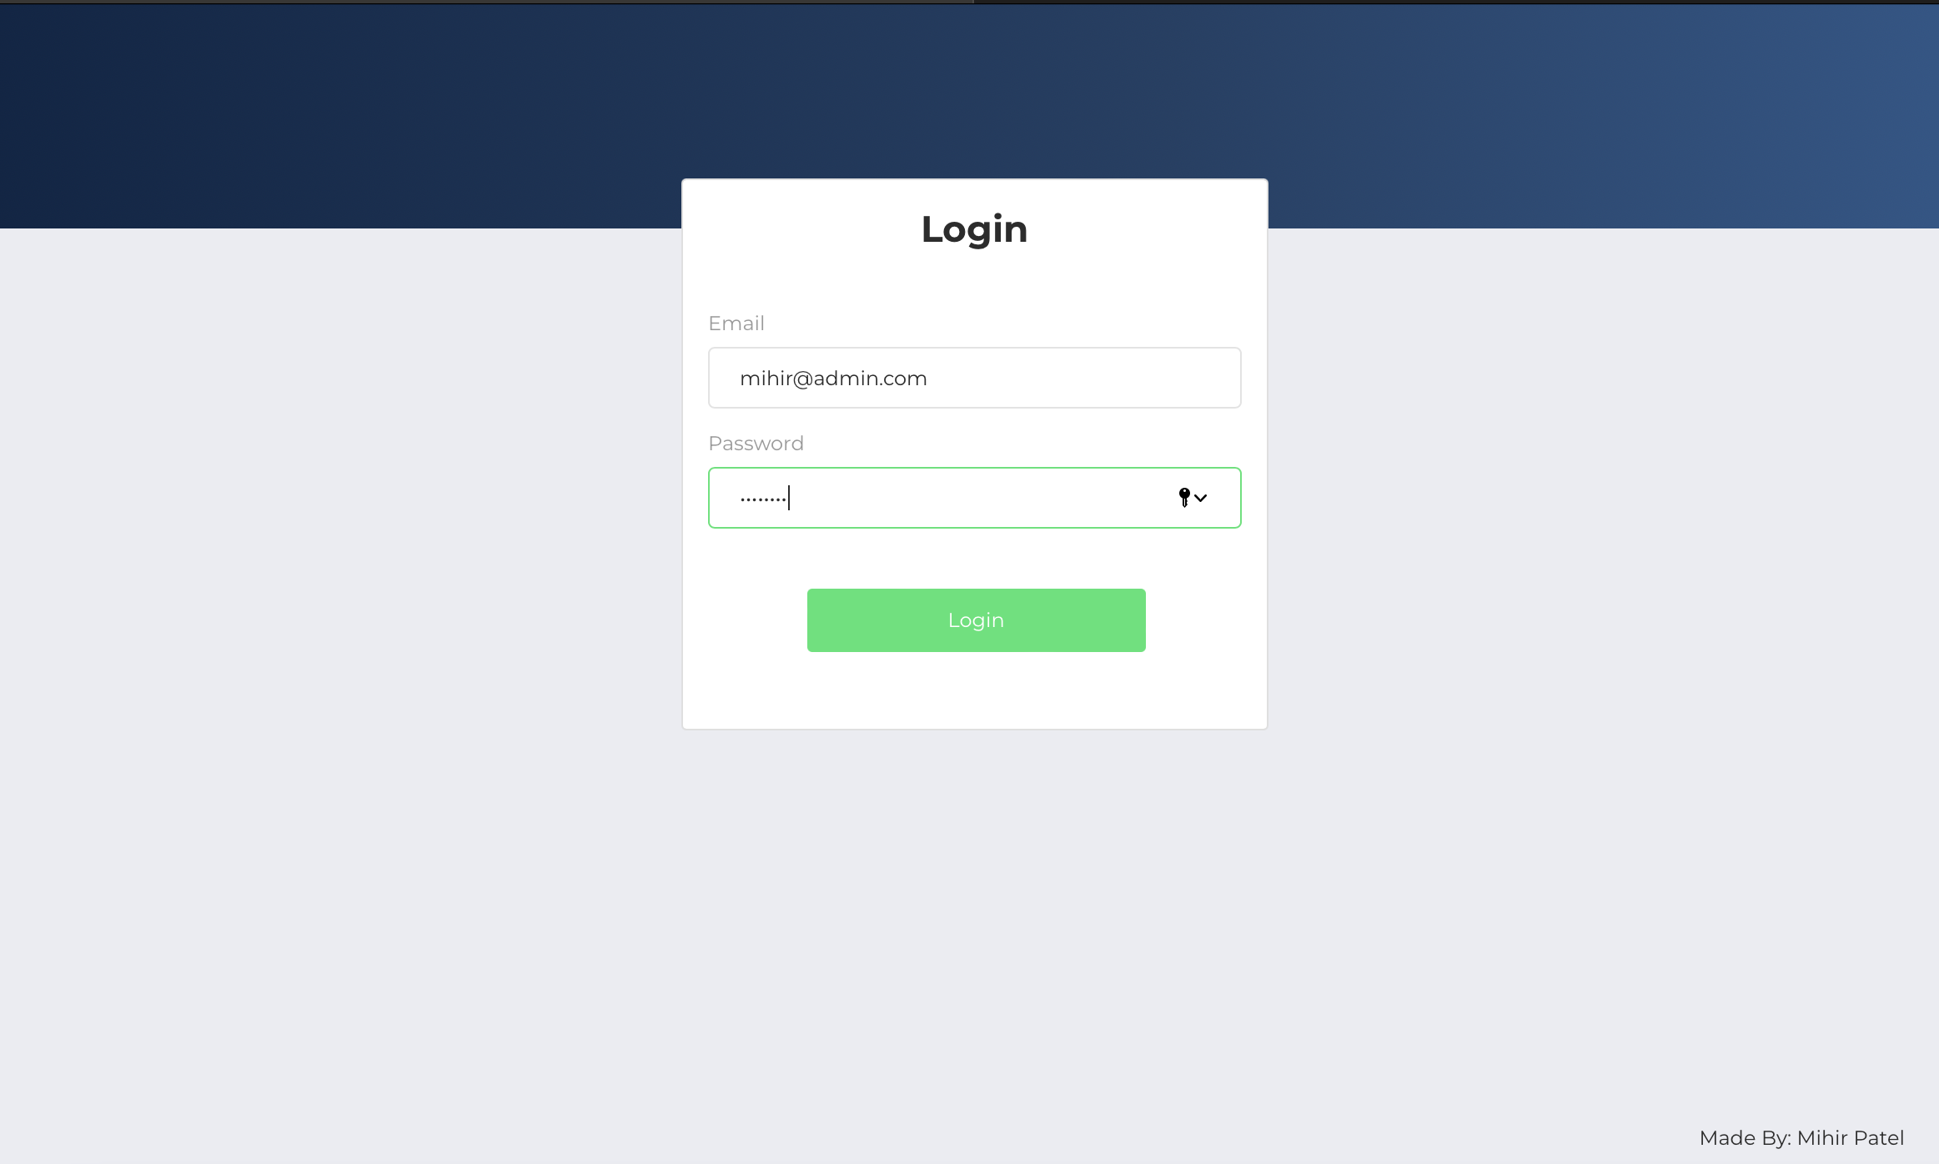

* By default, you will be on the dashboard page. So, you can move to the “Add Survey Group/Respondent” Page to create survey group and if needed then you can also add survey respondent one at a time.

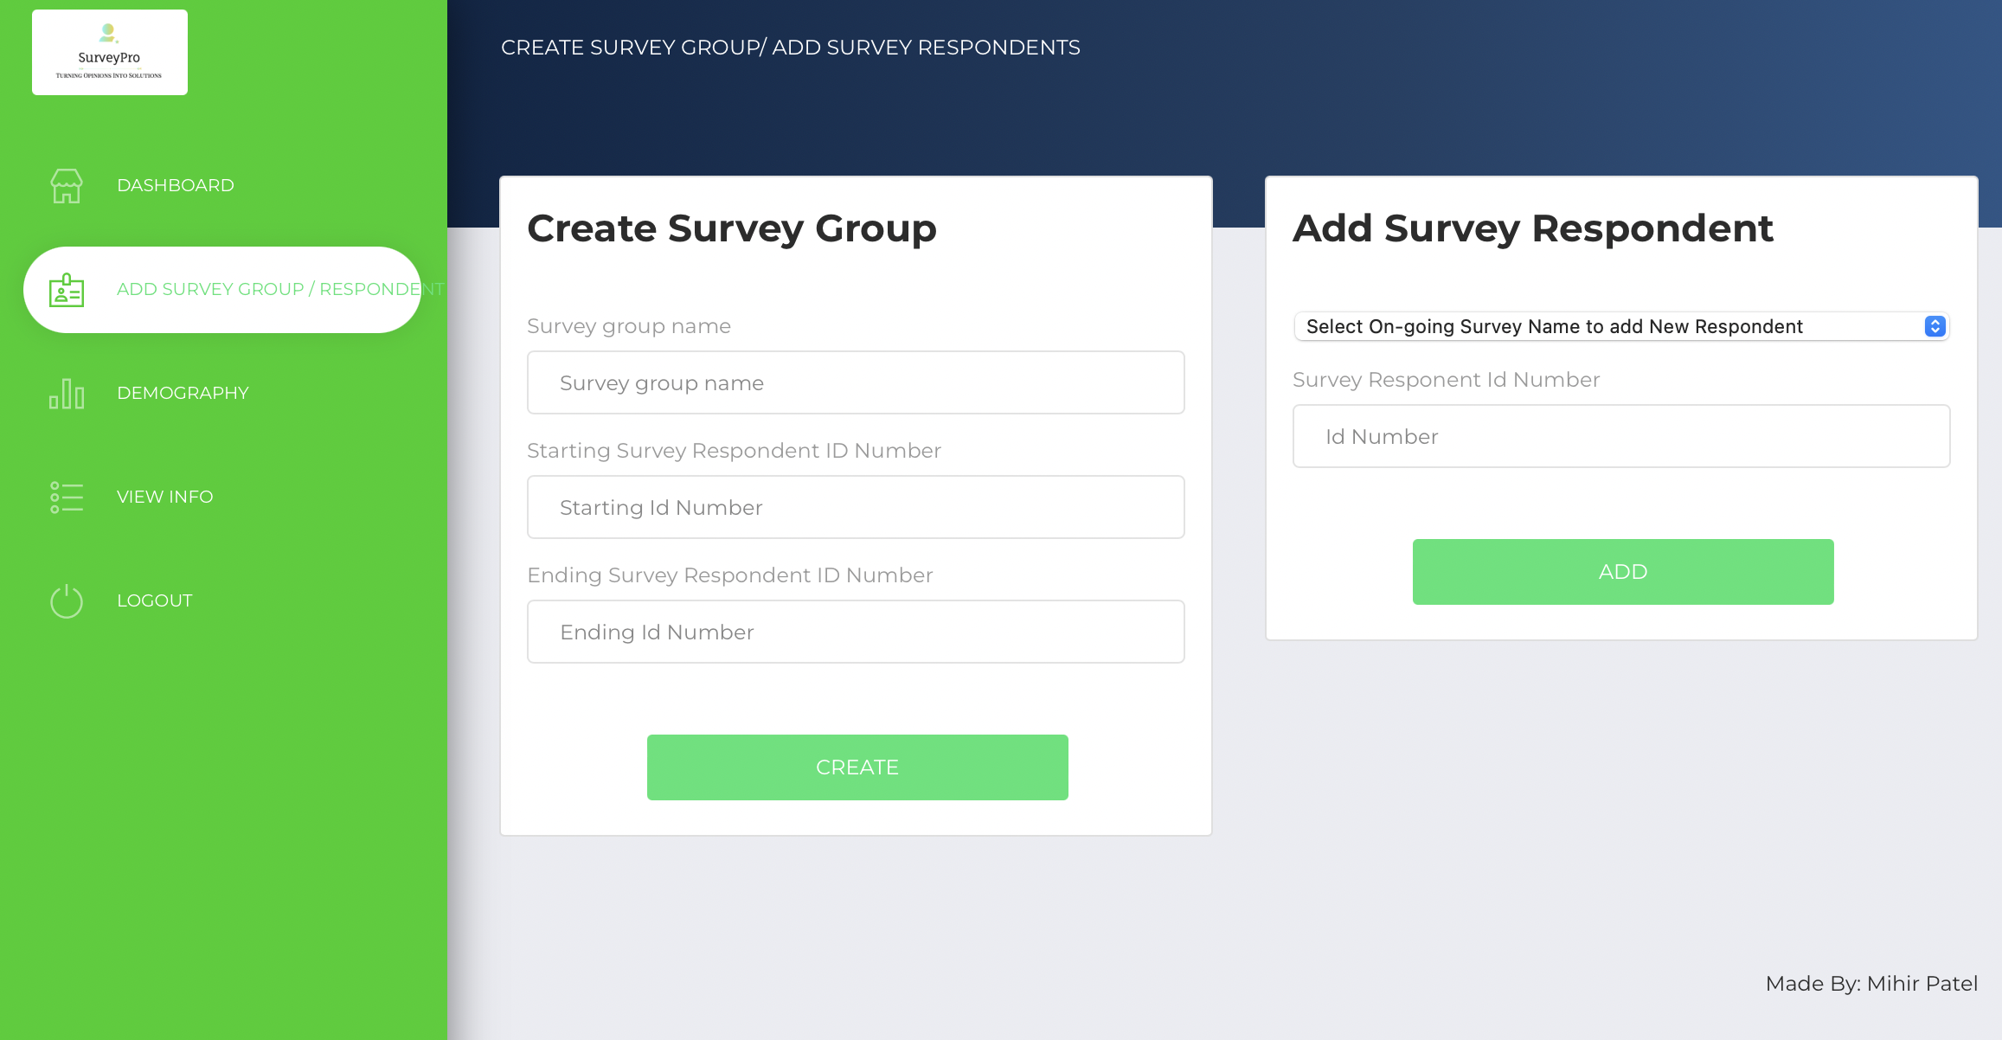

* Then on dashboard page, you can create a survey filling in some details. Make sure to keep the survey status to running so that you or other survey respondent can give the survey. If the survey is kept in pending status and the user logs in to his account then he will see nothing. So, it is necessary to keep the status to running.

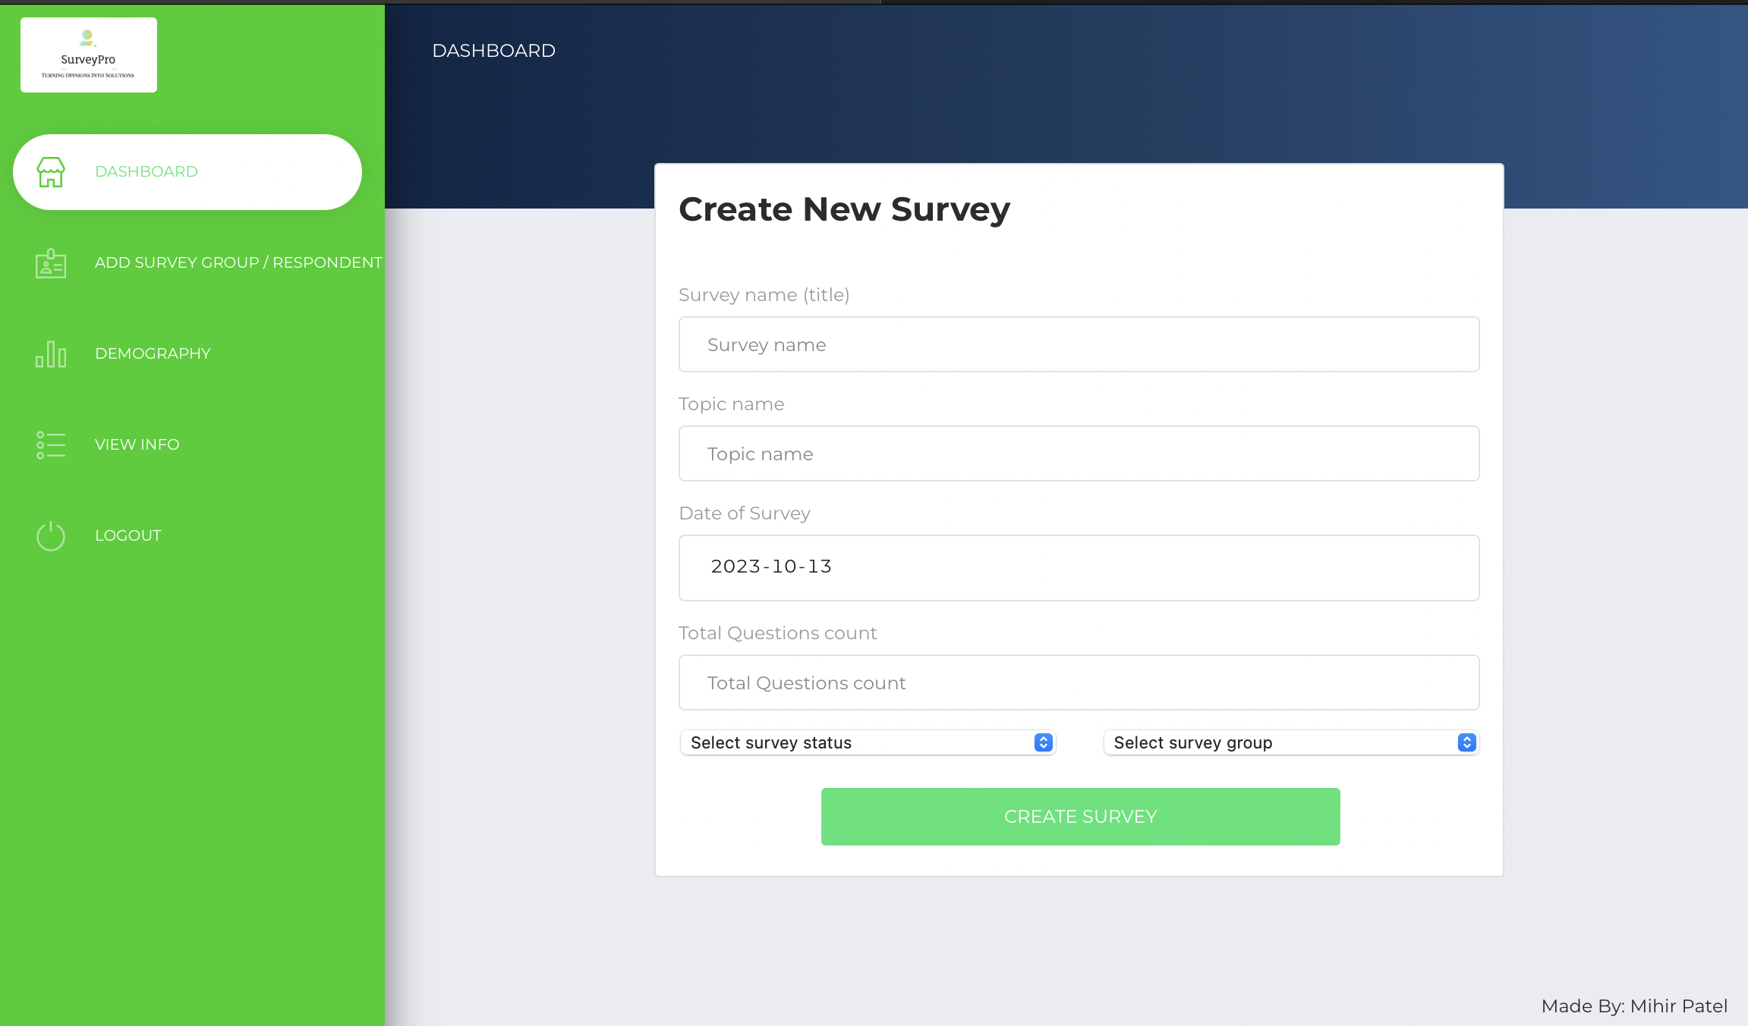

* On creating you will be able to see the name of your survey on the dashboard page.

You can update, delete, add new questions, add guest user and also make the status of the survey as completed on completion of the survey.

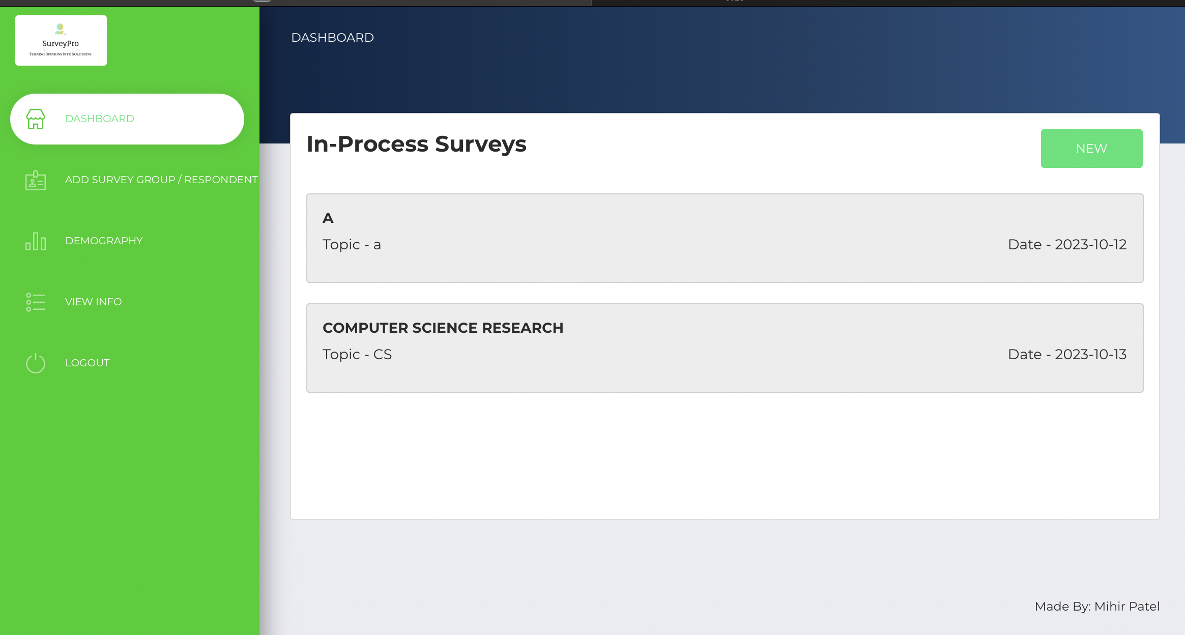

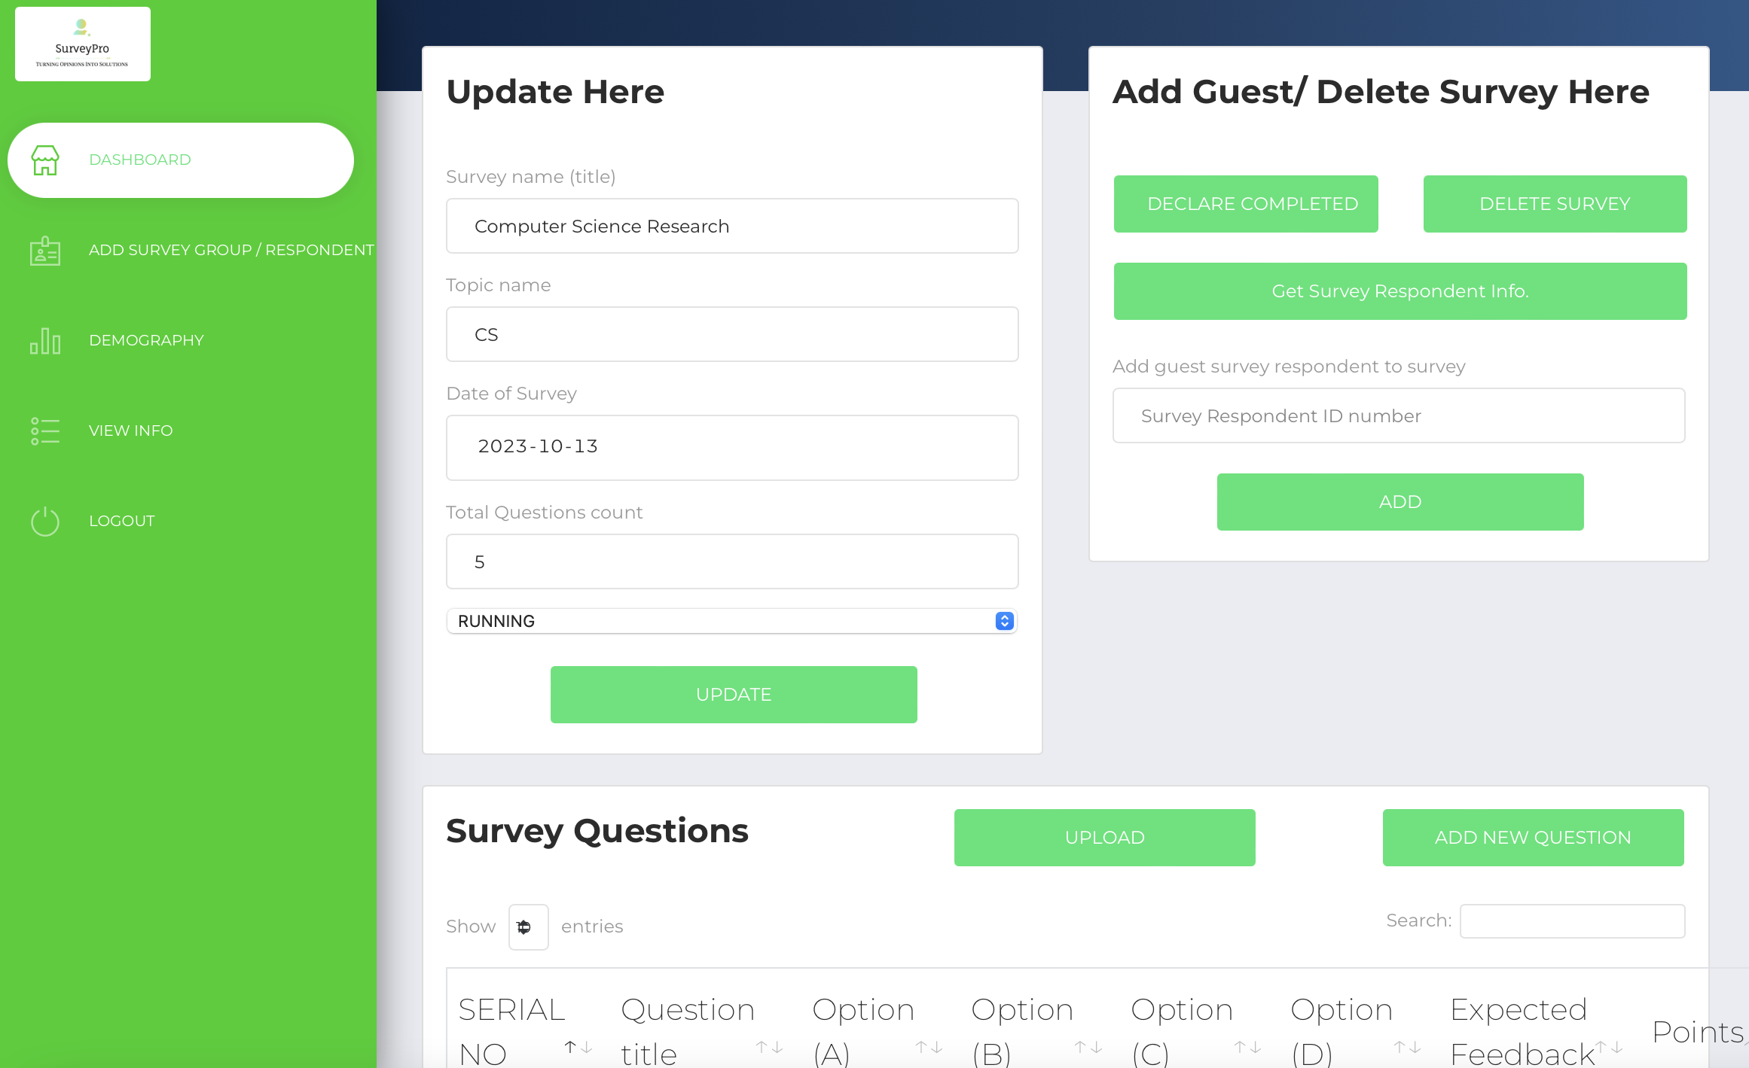

* On adding question to the survey. You can click on the button “Get Survey Respondent Info” to see their Respondent ID and Password that can be shared with individual users to give surveys.

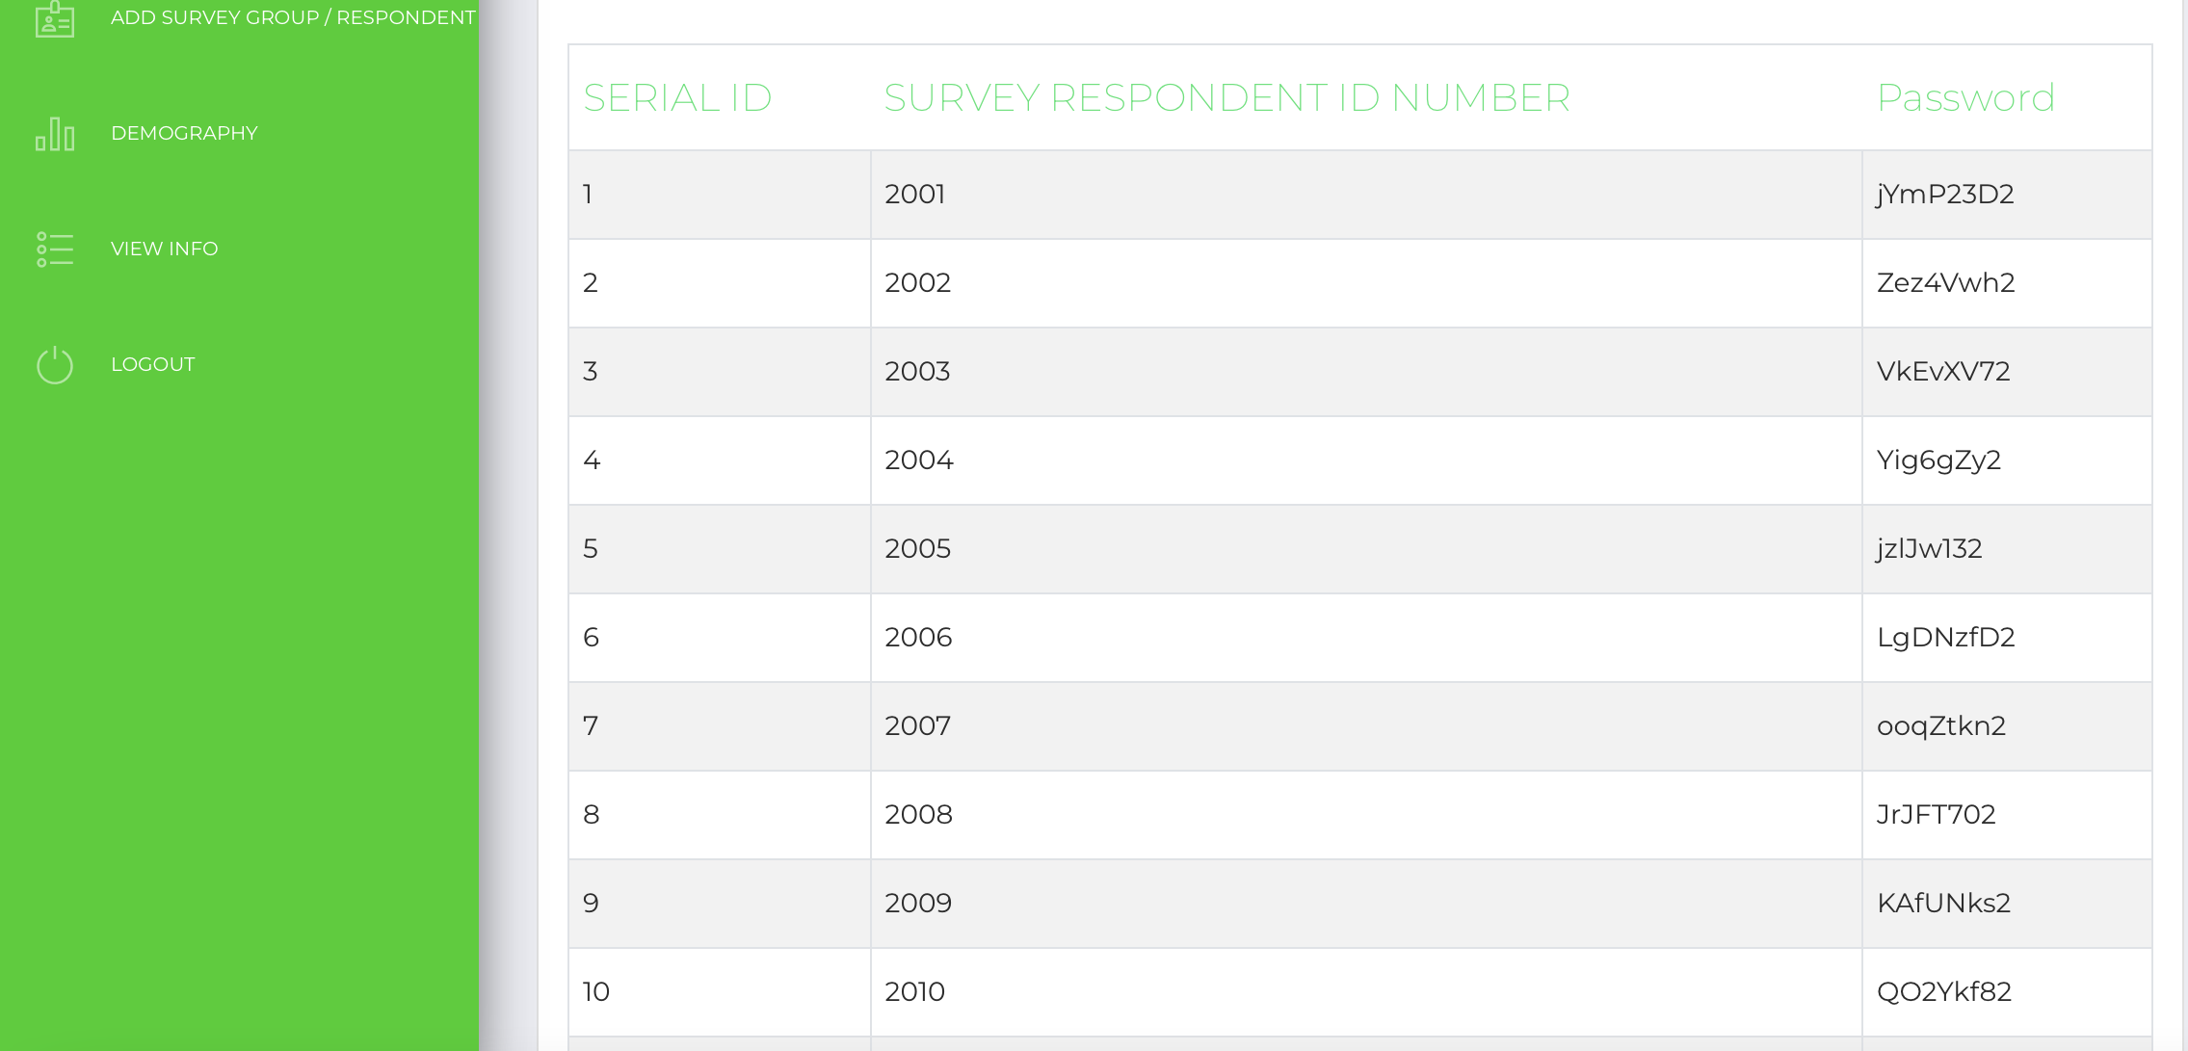

* For giving the surveys, the user can use the second link provided, enter his/her respondent id and password to give the survey.

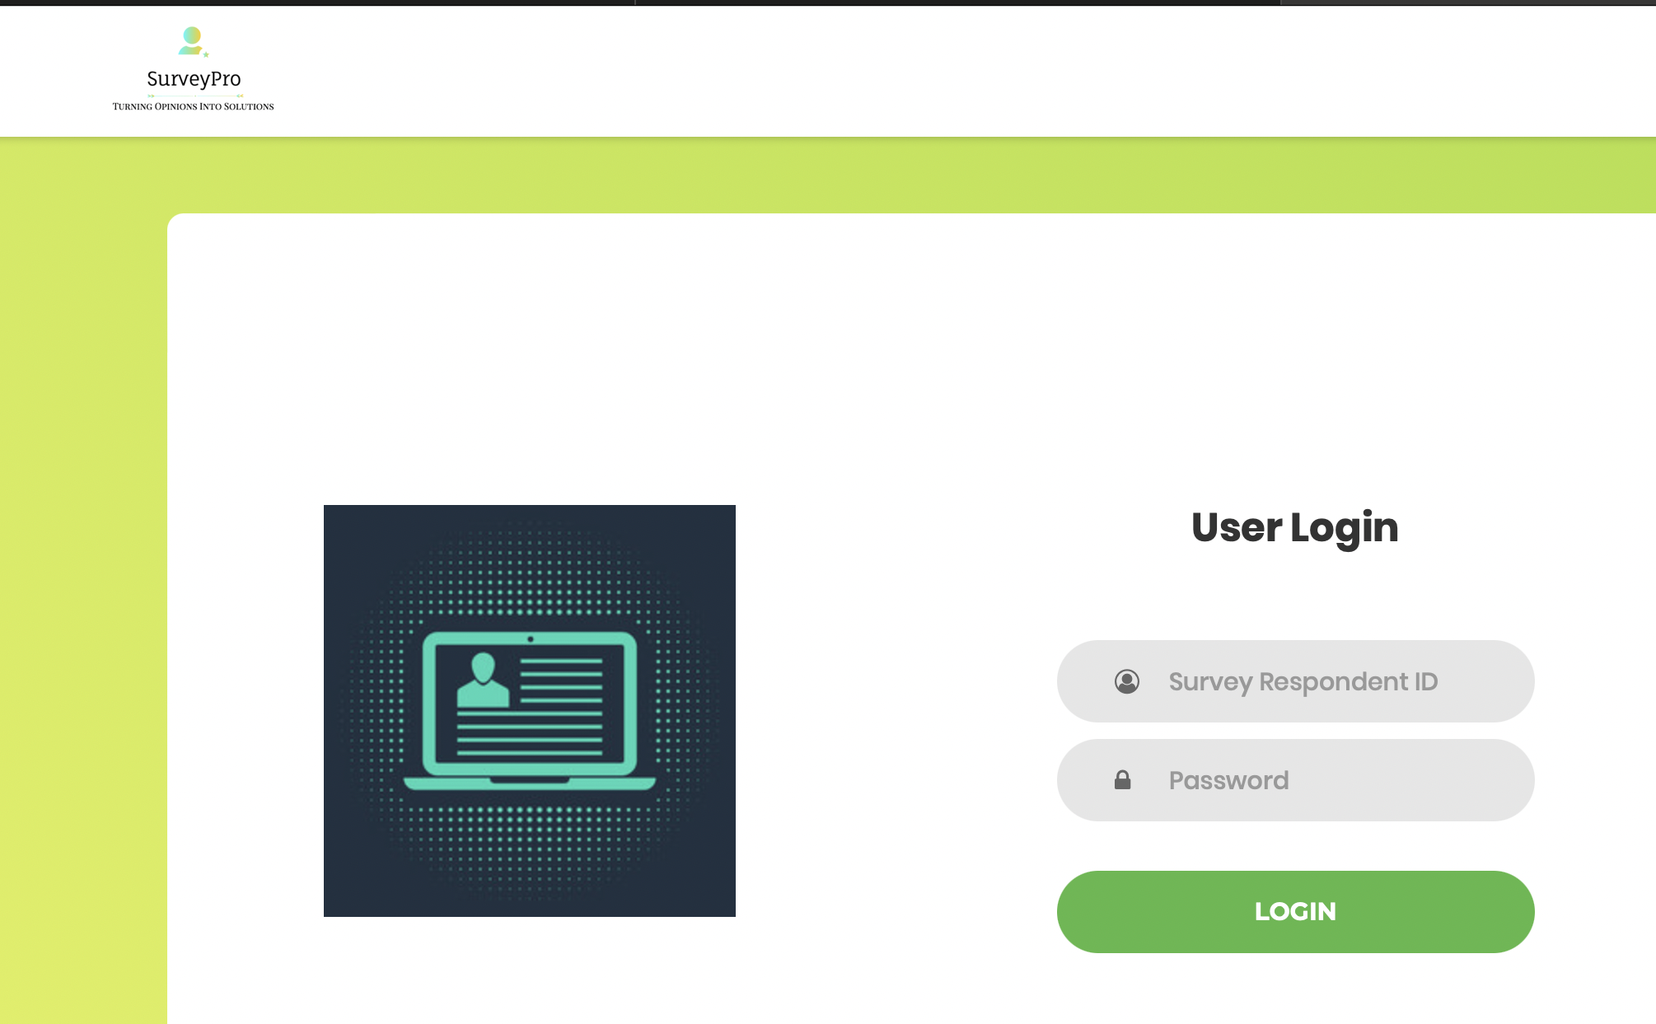

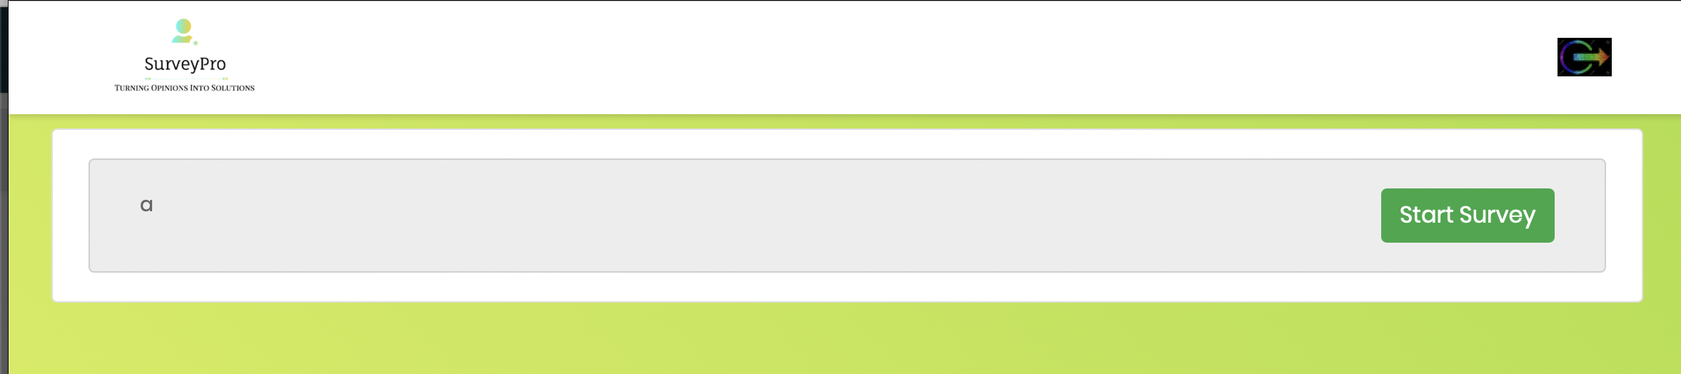

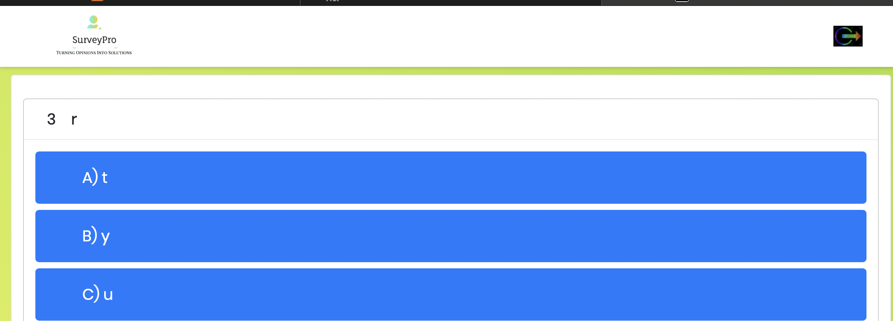

* After every respondent has given survey, the survey creator or the admin can declare the status of the survey as completed by clicking on the button “Declare Completed” on the admin dashboard page on clicking their survey which are currently in-process.

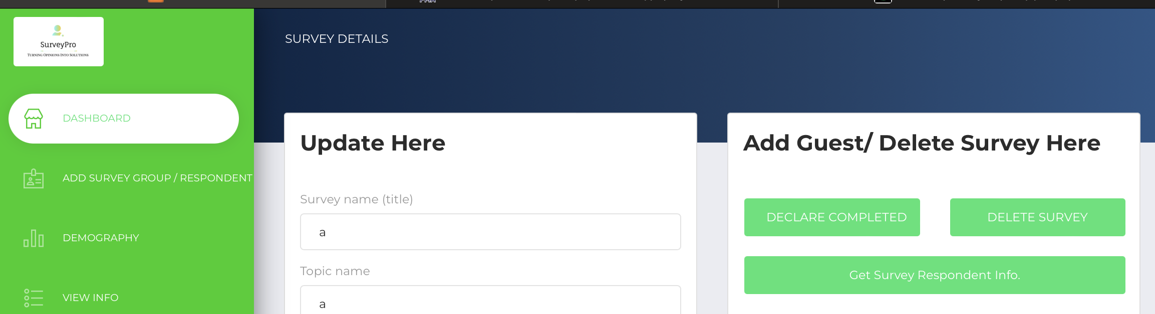

* The user can see how many users have provided surveys with the expected feedback. This page is under development currently for visualization of the results or feedbacks from different survey respondents.

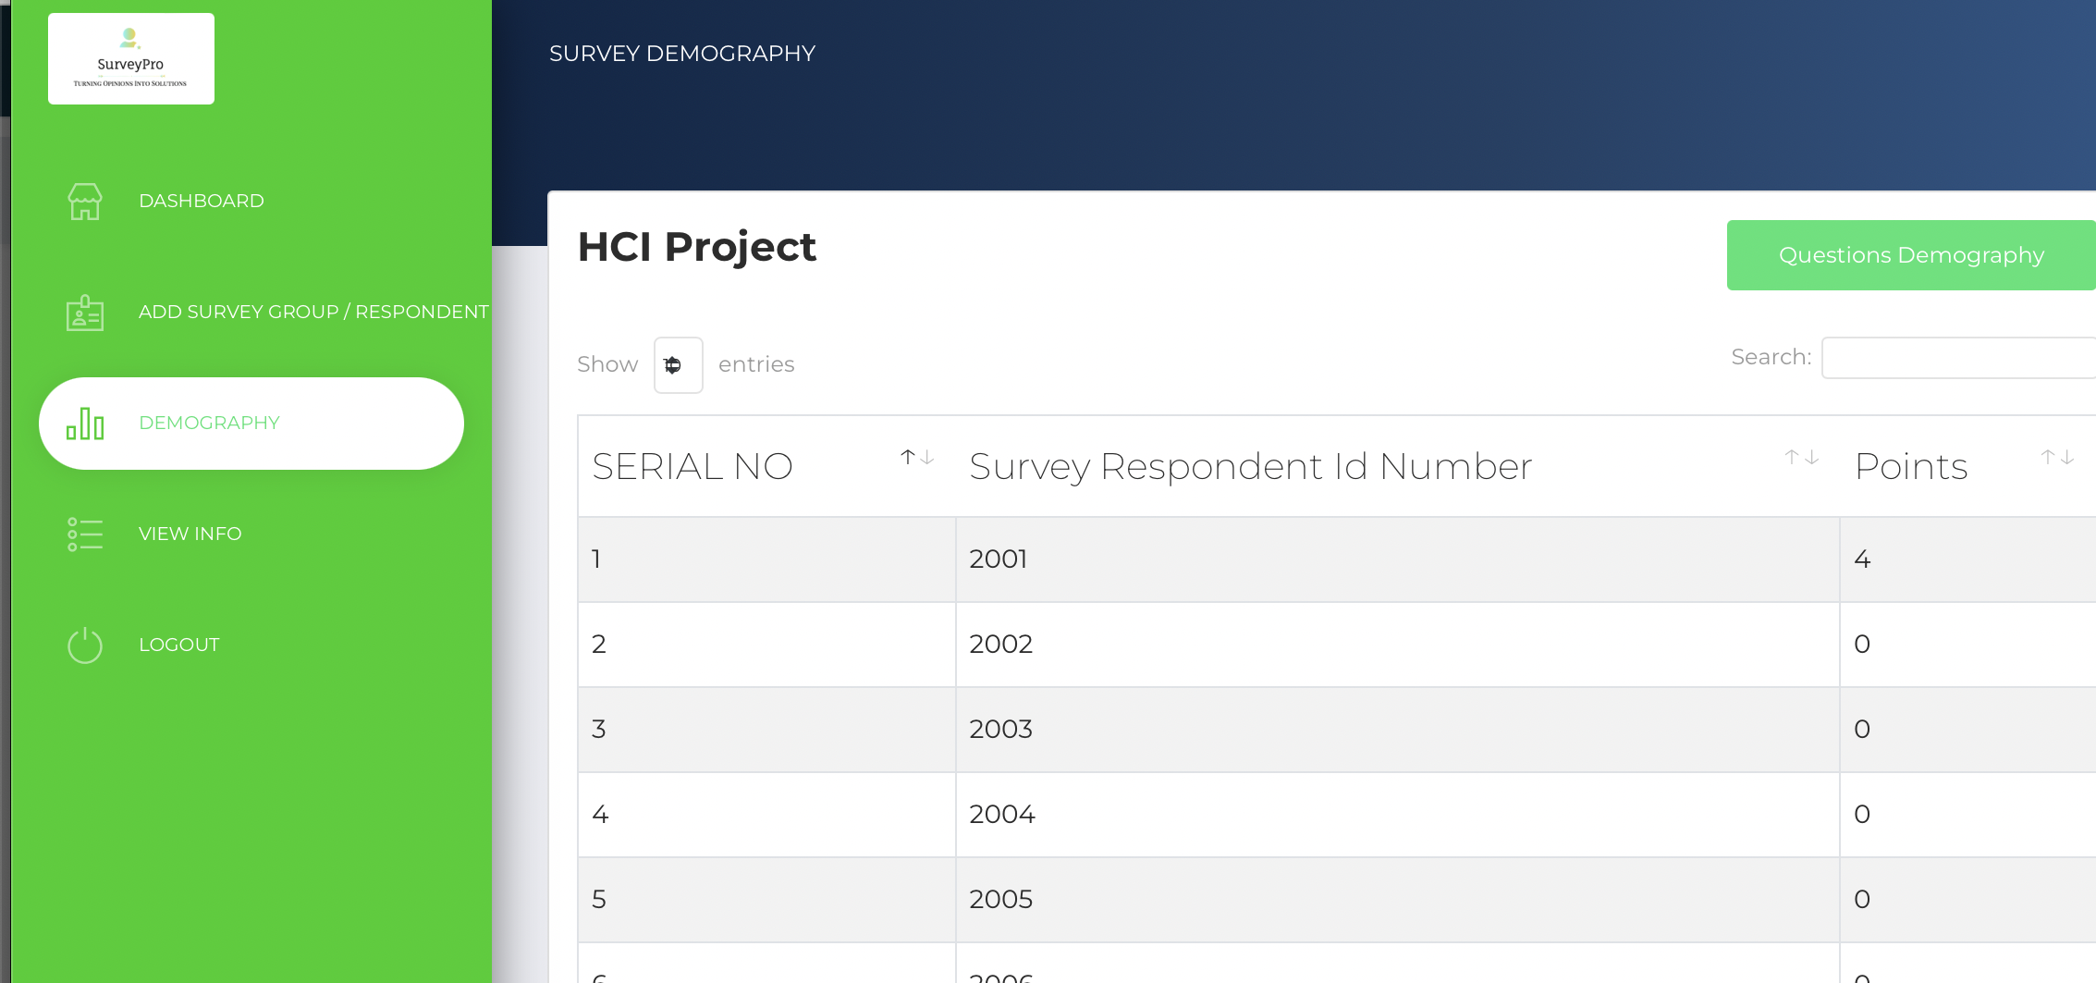

* On Completion, to exit, you can click on logout.

# **Bibliography**

Bostock, M. (n.d.). D3.js - Data-Driven Documents. <https://d3js.org/>

Free visual Sitemap generator from URL & XML Sitemap creator. (n.d.). Octopus.do, Visual Sitemap Tool, Website Planner, Architecture. <https://octopus.do/sitemap/resource/generator>

(n.d.). Google Forms: Sign-in. <https://forms.google.com/>

(n.d.). Matplotlib — Visualization with Python. <https://matplotlib.org/>

(n.d.). pandas. <https://pandas.pydata.org/>

Preece, J., Sharp, H., & Rogers, Y. (2015). Interaction design: Beyond human-computer interaction. John Wiley & Sons.

(2022, July 27). Qualtrics. <https://www.qualtrics.com/>

(n.d.). Stack Overflow. <https://stackoverflow.com/>

(n.d.). SurveyMonkey. <https://www.surveymonkey.com/>

(n.d.). Typeform. <https://www.typeform.com/>

(n.d.). YouTube. <https://www.youtube.com/@technobroad691>

(n.d.). YouTube. <https://www.youtube.com/watch?v=xdtzPHZXrVcs>

(n.d.). YouTube. <https://www.youtube.com/watch?v=VVkfSNwJOwc>

Now UI dashboard by creative tim. (n.d.). Premium Bootstrap Themes and Templates: Download @ Creative Tim. <https://www.creative-tim.com/product/now-ui-dashboard>